# Image result for clip art shredding **LOWER TOWNSHIP**

**COMMUNITY SHRED DAY**

**When: Saturday Oct 25, 2025** rain or shine

**9:00 am to 12:00 pm** or until Truck fills.

## undefined**Where:** **Behind Lower Township Municipal Complex.**

## ***2600 Bayshore Road (Villas)***

## **CHECK YOUR BOX BEFORE COMING TO SHREDDING EVENT!**

## **YOU WILL BE TURNED AWAY IF BOX CONTAINS:**

## BOOKS, BINDERS, MAGAZINES, X-RAYS, HARD DRIVES, PLASTIC COVERS, LAMINATED PAPER, METAL FOLDERS, SHREDDED PAPER ETC**.**

## **DO NOT RUBBER BANDS OR DUCT TAPE BOXES.**

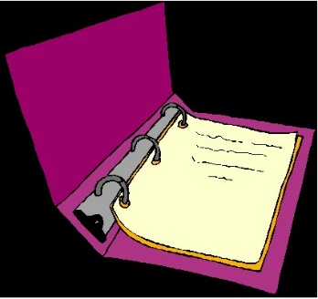Put non-confidential paper curb side on your trash day.

**Limit 4 boxes per vehicle.**

**FOR MORE INFORMATION CONTACT: 609-884-0898 ext 315**

LindaThomas, CRP, NJCCCC

Stay in vehicle! Keep plastic bags out of recycling!